**PERSONAL TUTORING SERVICE**

**TEAM 6**

**PHILOMATH**



**TEAM MEMBERS**

**Abrar Ullah Hussaini Syed**

**Asha Priya Atluri**

**Srikant Vadrevu**

**Supriya Saraogi**

**Vivek Kaushal**

**PROJECT SUMMARY**

Project included development of an android project for a large client oriented customer. The application provides the details of various tutors. A user can be a student or a tutor or both. He/she can search for a particular tutor either through their preferred course or category or by tutor name.

The contact details of all the tutors are available and can be contacted directly through the app. Even the student can locate the tutor near their vicinity. The tutor can advertise himself using this app by paying with charge of minimum amount. Also we are provided the users with tutorial so that they can see how the app works.

**PRODUCT BACKLOG AND SPRINT BACKLOG**

**PRODUCT BACKLOG**

**Component Name:** Registration

**Story Name:** Tutor Registration

**Story Sequence Number:** 001

**Story Short Description:** As a tutor I will get registered for tutoring.

**Story Long Description:** As a new tutor I will enter my name, phone number, address, email, course category, availability, pricing and security questions. I would like to set my password for my account. Also enter if I am willing to travel along with the radius. If not, give my location address.

**Component Name:** Registration

**Story Name:** Student Registration

**Story Sequence Number:** 002

**Story Short Description:** As a new student I will registered to access the courses.

**Story Long Description:** As a new student I will give my details like name, phone number, address, email and security questions. I will also set my password for my account.

**Component Name:** Tutoring Details

**Story Name:** Tutor Profile

**Story Sequence Number:** 003

**Story Short Description:** As a student I will retrieve tutor information.

**Story Long Description:** As a student I will retrieve tutor and course information from the search results. The results must include the name, phone number, email, address, courses he/she is teaching, availability, pricing and reviews. I also would like to contact the tutor through easy access buttons which can be either phone call or text message or email.

**Component Name:** ProfileDetails

**Story Name:** Edit Profile

**Story Sequence Number:** 004

**Story Short Description:** As a user (tutor/student) I would like to edit or update my profile.

**Story Long Description:** As a tutor I will edit or update my password, contact, availability, tutoring courses, pricing and address. As a student I will edit personal details like address, contact number, email and also my password.

**Component Name:** Search

**Story Name:** Search by Tutor

**Story Sequence Number:** 005

**Story Short Description:** As a student I would like to search tutors.

**Story Long Description:** As a student I will search tutors by entering his/her name or location. If searched by name, every tutor with that name should appear. If searched by location, every tutor within that vicinity should appear.

**Component Name:** Search

**Story Name:** Search by Category

**Story Sequence Number:** 006

**Story Short Description:** As a student I will search for courses.

**Story Long Description:** As a student I will search for courses using the category name. Every course in that category and all the tutors currently teaching that course must appear. I would like to search directly using the course name too.

**Component Name:** Tutor Reviews

**Story Name:** Review Page

**Story Sequence Number:** 007

**Story Short Description:** As a student I will review my tutors.

**Story Long Description:** As a student I will give my reviews to tutors in different categories on the scale of 0 to 5. A page should appear to give reviews.

**Component Name:** Tutor Reviews

**Story Name:** Review Functionality

**Story Sequence Number:** 008

**Story Short Description:** As a student I will review my tutors.

**Story Long Description:** As a student I will give my reviews to tutors in different categories on the scale of 0 to 5. I should be able to give reviews only for the courses I enrolled.

**Component Name:** Location

**Story Name:** Locate the Tutor

**Story Sequence Number:** 009

**Story Short Description:** As a student I would like to know the location of the tutor.

**Story Long Description:** As a student I want to locate the tutor using Google Maps. I would like to redirect to Google Maps for navigation details.

**Component Name:** Login & Authentication

**Story Name:** User Login

**Story Sequence Number:** 010

**Story Short Description:** As a user I will login into the application

**Story Long Description:** As a user (student/tutor) I will login into my account using my email as username and password. If I enter my username or password incorrect a pop-up should appear saying username or password incorrect.

**Component Name:** Login & Authentication

**Story Name:** Forgot Password?

**Story Sequence Number:** 011

**Story Short Description:** As a user I would like to have an option to recover my account in case I forget my password.

**Story Long Description:**  As a user I will reset my password using the either by answering the security questions or through recovery email.

**Component Name:** Advertising the tutor

**Story Name:** Tutor Advertisement

**Story Sequence Number:** 012

**Story Short Description:** As a tutor I should be able to advertise my courses.

**Story Long Description:** As a tutor I would like to advertise or feature my courses. Featured courses will be shown first in the search results.

**SPRINT BACKLOG**

|  |  |  |  |  |
| --- | --- | --- | --- | --- |
| **SPRINT 1 – February 11 to February 25 – Asha Atluri (scrum master)** | | | | |
| **Story Sequence Number** | **Story Name** | | | **Number of Days** |
| **010** | **User Login** | | | **3** |
| **011** | **Forgot Password?** | | | **3** |
| **001** | **Tutor Registration** | | | **2** |
| **002** | **Student Registration** | | | **2** |
| **SPRINT 2 – February 25 to March 10 -** | | | **Supriya Saraogi** |  |
| **004** | **Profile Details** | | | **5** |
| **006** | **Search by Category** | | | **4** |
| **SPRINT 3 – March 10 to March 31 -** | | **Abrar Syed** | | **`** |
| **003** | **Tutor Profile** | | | **5** |
| **005** | **Search by Tutor** | | | **4** |
| **SPRINT 4 – March 31 to April 14 -** | **Srikant Vadrevu** | | |  |
| **009** | **Locate the tutor** | | | **7** |
| **007** | **Review Page** | | | **3** |
| **SPRINT 5 – April 14 to April 28 -** | **Vivek Kaushal** | | |  |
| **008** | **Review Functionality** | | | **3** |
| **012** | **Tutor Advertisement** | | | **7** |

**BURNDOWN CHART**

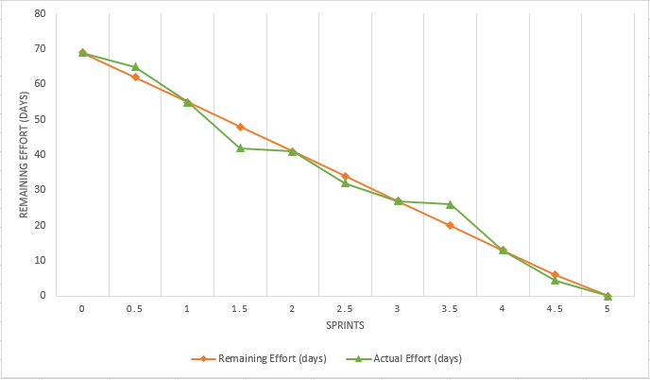

**ALTERED STORIES**

Initially we have taken only one story for review tutor but later on we have divided into 2 stories as the time required to implement it was more than our earlier estimation. There were no other alterations done to the stories and we have delivered every story successfully.

**INCOMPLETE STORIES**

All the stories which the team and client have decided initially were developed and tested successfully. During sprint 2 and sprint 4 there were minor issues which took more days than the initial estimated days but at the end we were able to deliver the product with all the requirements of the client and with no issues.

**FUTURE ENHANCEMENTS**

1. Making this application compatible with various other platforms like iOS, windows etc.
2. The application can be upgraded by adding voice search functionality in the search page. When a user wants to search for a particular course he can search by giving a particular course or category or tutor name through this voice search functionality.
3. Also in-app chat communication between the tutor and student can be added so that there is no need for the student to send a message or email to know the basic information regarding the tutor the course he/she is teaching.
4. There can be an upgrade of retrieving the information of 5 tutors nearer to the student who are within 10 miles of the student’s vicinity when he searches.

**MAJOR ISSUES PENDING**

There are no major issues that would cause the delay of the project or cause any interruption to the end user. But we have a maintenance team which will handle the issues or bugs that would arise in the future.

**CONCLUSION**

Our team at Philomath worked hard and coordinated very efficiently to make the delivery on time. We will look forward for extending the contract for Phase-2 of the app with the suggested enhancements.